**CSA1636-DATA WAREHOUSING AND DATA MINING**

**CAPSTONE PROJECT**

**PROJECT TITLE**-Predictive Analysis for Agricultural Yield Optimization for Crops in data mining.

**Done By**

1.Y.PARTHASARADHI (192211744)

2. M. GIRISH (192110005)

3. G. GOWTHAM (192211662)

4.M.SAI AKASH (192110237)

**PROBLEM STATEMENT:**

The goal of this project is to create a predictive analysis model using data mining techniques to optimize agricultural yield for various crops. By gathering historical and real-time data on weather, soil conditions, crop types, and farming practices, the model aims to accurately forecast crop yields and help farmers make informed decisions about planting, resource allocation, and crop management strategies. Through data preprocessing, feature selection, and model training, the project seeks to develop a reliable predictive tool that can be integrated into existing agricultural systems, enabling stakeholders to improve crop productivity and sustainability while minimizing risks associated with unpredictable environmental factors and market fluctuations.

**PROPOSED DESIGN WORK:**

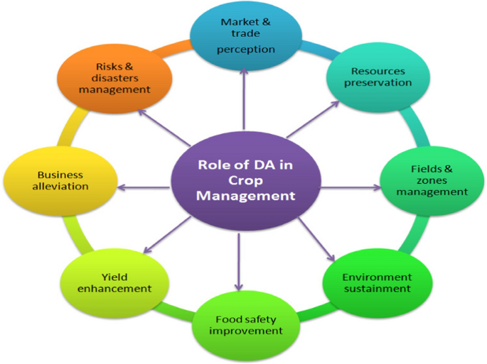

**IDENTIFYING KEY COMPONENTS:**

1. **Data Collection and Integration**

2. **Data Preprocessing**

3. **Feature Selection and Engineering**

4. **Model Selection and Training**

5. **Validation and Evaluation**

6. **Model Interpretation and Visualization**

7. **Deployment and Integration**

**FUNCTIONALITY:**

Predictive Analysis for Agricultural Yield Optimization employs data mining techniques to enhance crop productivity and inform decision-making in farming. By analysing diverse datasets encompassing historical yields, weather patterns, soil characteristics, and agronomic practices, predictive models forecast crop yields with accuracy. These models enable farmers to anticipate yield fluctuations, mitigate risks, and optimize resource allocation.

**1.YIELD PREDICTION:**

This functionality involves developing models to predict crop yields based on various factors such as historical yield data, weather conditions, soil quality, irrigation practices, and crop types. Data mining techniques like regression analysis, machine learning algorithms, and time-series forecasting methods are employed to build predictive models that can estimate future crop yields accurately. By predicting yields, farmers can make informed decisions regarding planting schedules, resource allocation, and harvest planning, thereby optimizing agricultural productivity.

**2.RISK ASSESMENT AND MITIGATION:**

Another critical functionality of predictive analysis in agriculture is assessing and mitigating risks associated with crop production. Data mining techniques enable the identification of potential risks such as pest infestations, disease outbreaks, adverse weather events, and market fluctuations that may impact crop yields. By analysing historical data and patterns, predictive models can forecast the likelihood and severity of these risks, allowing farmers to implement proactive measures to mitigate them.

**3.OPTIMIZATION OF AGRICULTURAL PRACTICES**

Predictive analysis facilitates the optimization of agricultural practices by providing insights into the factors that influence crop yields and identifying opportunities for improvement. Through data mining techniques, patterns and correlations between various agricultural inputs such as fertilizer usage, irrigation levels, crop rotation strategies, and soil management practices can be analysed to optimize resource allocation and enhance yield outcomes. By leveraging predictive models, farmers can optimize their agricultural practices to maximize productivity while minimizing resource waste and environmental impact.

**ARCHITECTURAL DESIGN:**

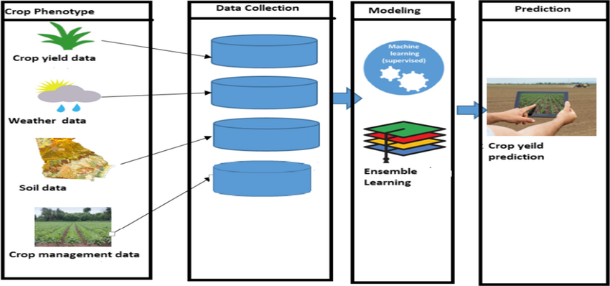

**UI Design:**

**Layout Design:**

**Crop Yield Production:**

Implement the trained predictive model to predict crop yields based on input parameters such as weather conditions, soil characteristics, and crop types. Present predicted yields through interactive dashboards or visualizations for easy interpretation.

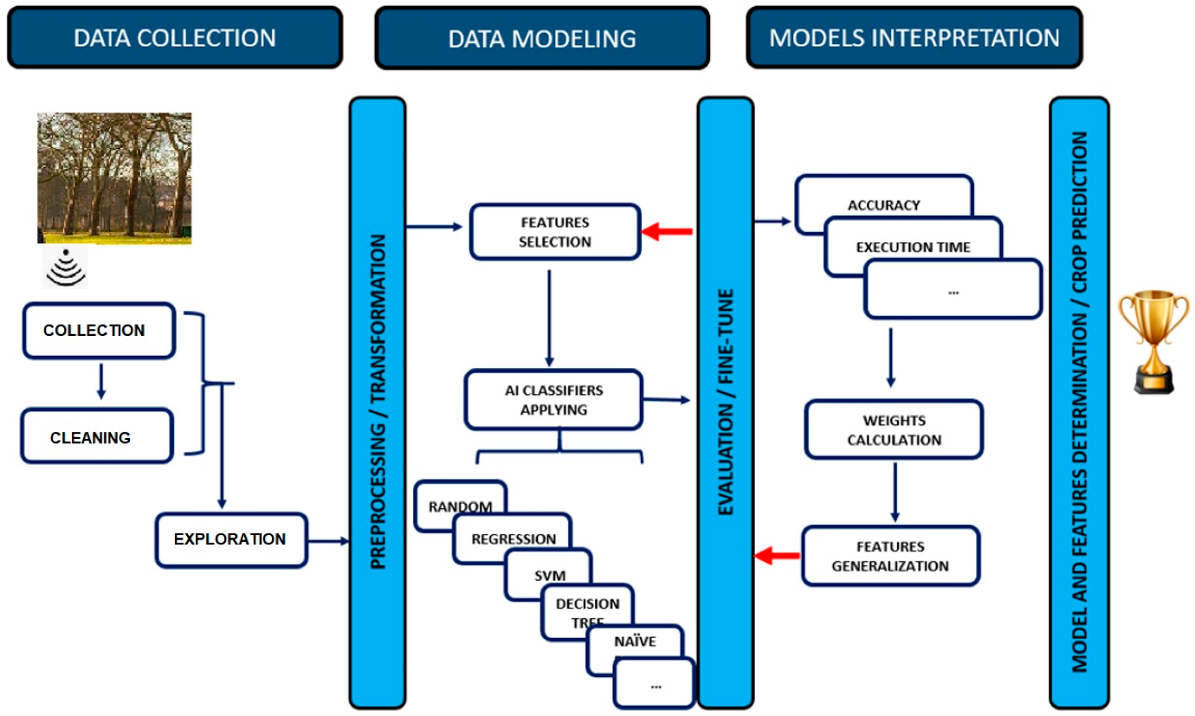

**Optimization strategies:**

Develop recommendation systems to suggest optimal crop varieties, planting dates, irrigation schedules, and fertilizer usage based on predicted yields. Conduct sensitivity analysis to assess the impact of different factors on crop yields and optimize agricultural practices accordingly.

**Continuous improvement:**

Incorporate feedback from farmers, agronomists, and other stakeholders to improve model accuracy and relevance. Regularly update predictive models with new data to adapt to changing environmental conditions and farming practices.

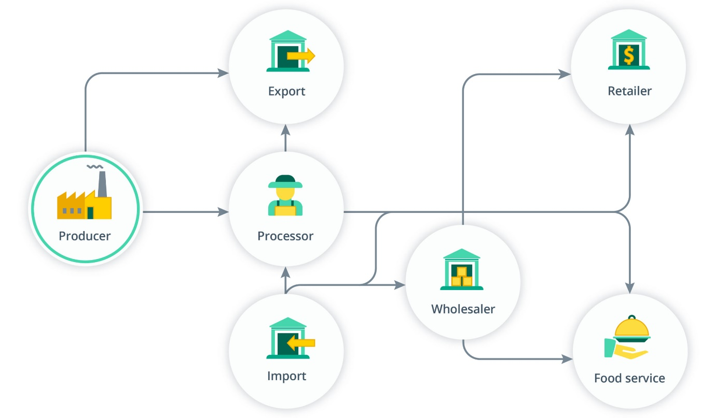

**FEASIBLE ELEMENTS USED:**

**Weather data:** Weather data plays a crucial role in agricultural yield prediction. Variables such as temperature, precipitation, humidity, wind speed, and solar radiation are important factors that affect crop growth and development.

**Soil data:** Soil characteristics such as pH, nutrient levels, organic matter content, soil texture, and moisture levels significantly impact crop yields. Soil data is usually collected through soil sampling and laboratory analysis.

**Crop management practices:** Information about crop management practices, including planting dates, irrigation schedules, fertilization regimes, pesticide applications, and crop rotation practices, can help improve predictive models by understanding their impact on crop yields.

**Elements Function:** In predictive analysis for agricultural yield optimization, several essential elements function together synergistically. Historical yield data serves as the foundation, capturing past crop performance and management practices. Weather data provides crucial insights into environmental conditions, influencing crop growth and development. Soil characteristics offer valuable information on nutrient levels, moisture content, and soil health, guiding agronomic decisions. Geospatial data, including satellite imagery, contributes to monitoring crop health and identifying spatial variability across fields. Pest and disease data inform pest management strategies, helping farmers mitigate risks and protect crop yields.

**LOGIN TEMPLATE:**

**Login process/signup process:**

**User Registration:**

User provides necessary details such as name, email address, password, and any additional required information.

Validate the provided information, including email format and password strength.

Store the user data securely in a database, encrypting sensitive information like passwords.

**Login process:**

Users enter their registered email address and password.

Authenticate the user by verifying the entered credentials against the stored data.

Upon successful authentication, grant access to the user dashboard or application features.

Implement measures like CAPTCHA or two-factor authentication for added security.

**Access control:**

Assign roles and permissions to users based on their roles (e.g., admin, regular user).

Restrict access to certain features or sections based on user roles and permissions.

Implement session management to maintain user sessions securely.

**Future data Extraction:**

Collect user activity and interaction data for future analysis and improvement.

Utilize analytics tools to gather insights into user behaviour, preferences, and usage patterns.

Implement feedback mechanisms to gather user suggestions and preferences for future enhancements.

Deploy the login system and user registration functionality on a secure server or cloud platform

**Deployment:**

Deploy the login system and user registration functionality on a secure server or cloud platform.

Ensure high availability and scalability to accommodate growing user base and traffic.

Implement security best practices such as HTTPS, encryption, and firewall configurations.

**Enhanced user Experience:**

Implement a responsive and intuitive user interface for seamless navigation and interaction.

Provide clear instructions and error messages to guide users through the registration and login processes.

Offer personalized recommendations and content based on user preferences and behaviour

Enable social login options for convenience and faster registration/login process.

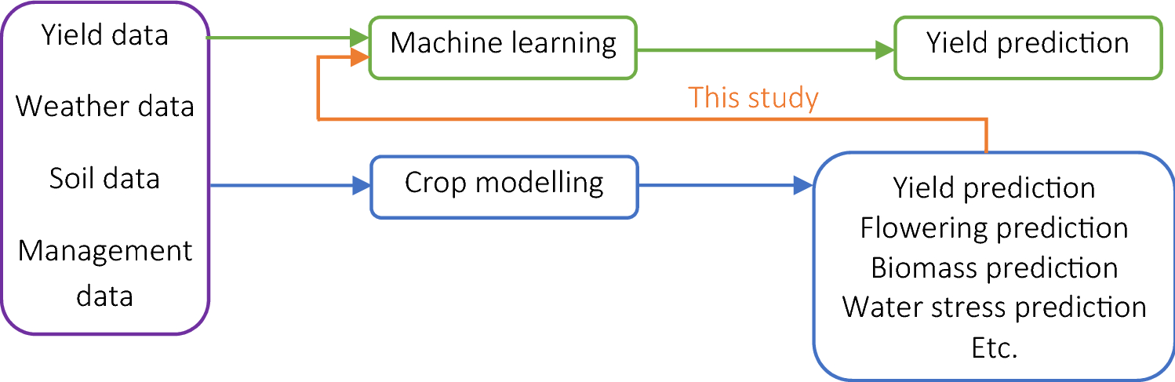

**Other Template:**

Deploy the trained model into a production environment for real-time predictions. Integrate the model with existing agricultural systems or platforms to provide actionable insights to farmers and stakeholders, fostering seamless adoption and utilization. Continuously monitor model performance and update it as new data becomes available.

Roll out the trained model into the operational environment, ensuring compatibility with existing infrastructure and software systems. Seamlessly integrate the model's predictions into decision support tools accessible to farmers and stakeholders, promoting user-friendly interfaces and intuitive interaction. Establish robust monitoring mechanisms to track the model's performance in real-world scenarios, facilitating timely adjustments and optimizations to maximize its effectiveness in optimizing agricultural yield.

This revision emphasizes the importance of seamless integration and adoption of the predictive model within existing agricultural systems, ensuring that farmers and stakeholders can easily access and utilize the insights generated by the model to enhance decision-making and optimize yield.

**Conclusion:**

In conclusion, leveraging predictive analysis for agricultural yield optimization enables informed decision-making and resource allocation, fostering sustainable farming practices. By harnessing data mining techniques, stakeholders can enhance crop productivity, mitigate risks, and adapt to dynamic environmental factors, ensuring long-term agricultural resilience and prosperity.